Technical Assessment Test Report

Question 1 - Pass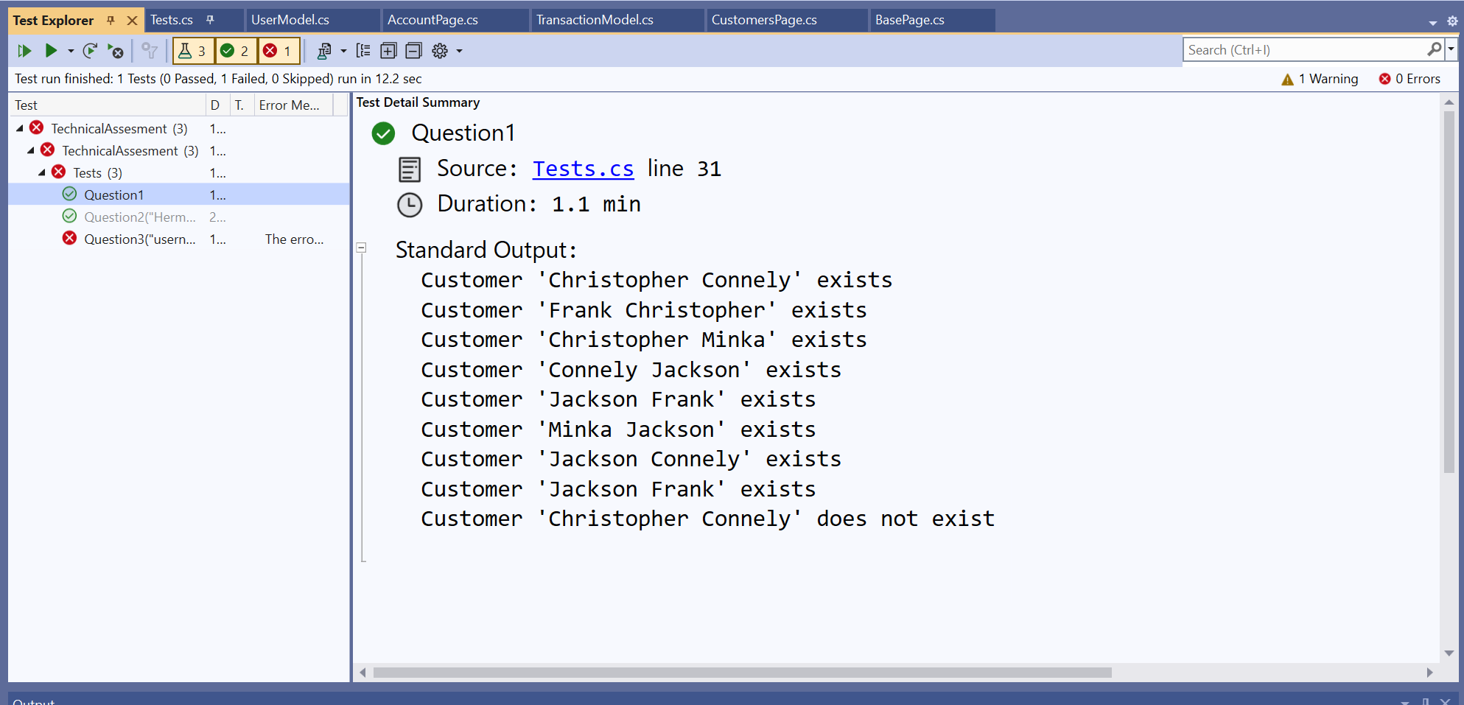

Question 2 - Pass

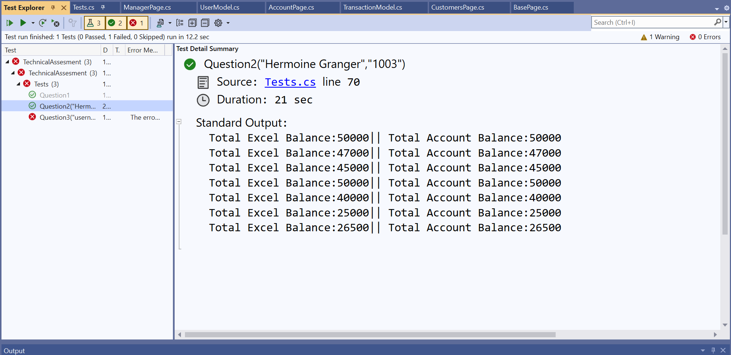

Question 3 – Failed

Only the GET /user/loginUser endpoint works, the others does not work. It may be due to a bug on the API.

1. The user “BruceWayne” can be logged in 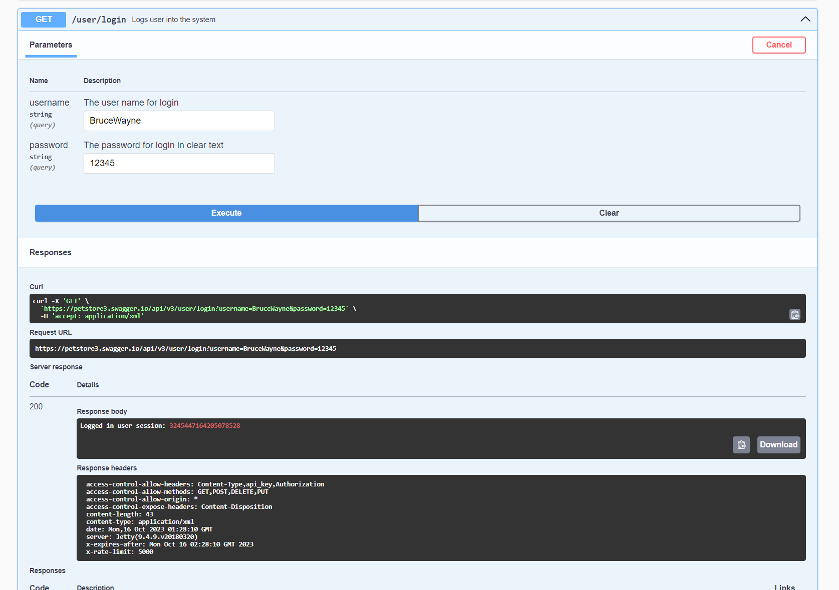
2. But the GET /user/{username} endpoint return error 404 for “BruceWayne” 